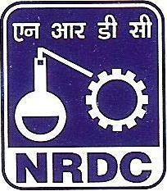
NATIONAL RESEARCH DEVELOPMENT CORPORATION
[An Enterprise of DSIR, Ministry of Science & Technology, Government of India]

HQ: 20-22, Zamroodpur Community Centre, Kailash Colony Extension, NEW DELHI-110048

Intellectual Property Facilitation Centre (IPFC)
Technology & Innovation Support Centre (TISC)
Innovation valley, APIS, Hill No-3, Plot No. 13&14, Rushikonda,
Visakhapatnam, Andhra Pradesh-530 045
E-Mail: bksahu@nrdc.in; Mobile: 9810104163

Website: http://www.nrdcindia.com

NRDC FORMAT FOR PROVIDING INFORMATI ON INVENTIONS FOR PATENTING

Please read the instructions at the end of this document before filling

- To be filled and submitted in ThreeSets

- Title of Invention:

AGROFILOS

- Particulars of Applicant (s):

Sl # | Name | Qualification | Designation
1. | Aadi Mishra | Student (class X) | Individual
2. | Ayushman Sahoo | Student (class X) | Individual
3.
4.
5.
6.

- Organisation Name andAddress

Organisation Name and Address | Applicant’s Postal Address
AIC-Nalanda Institute of Technology Foundation  Buddhist Villa, Chandaka,  Bhubaneswar-751024 | 1404, Tower 9, Vipul Gardens, Kalinga Nagar, Bhubaneswar, 751003  940/7383, Sidheswar Nagar, Jagamara , Bhubaneswar, 751030
Telephone: +91-9937825330 | Telephone: 8984627405,
Fax: | Fax:
Email:incmgr@aicnalanda.com | Email: aadimishra1958@gmail.com , ayushmansahoo343@gmail.com

- Stage of Development:
Product : Prototype

- Test Status:

Self tested

Status of Patent (if provisional application filed): Patent Pending No.: with Date Patent Specifications (Provisional/Complete) enclosed: Yes/No

No.
Fresh Application for Provisional Patent

- Brief abstract of invention (In about 500words):

AGROFILOS is India's first automatic multipurpose pesticides sprayer which aims to help the farmers to reduce their efforts in the field.
●It will help the farmer to spray pesticides/herbicides/insecticides/fertilizers without any physical strain or snake bites.
●She/he can control the machine using its Radio Frequency remote from a distance of more than 100m. Its speed and the pressure of the pump can controlled from the remote itself. Unlike the agri-drones, it can be operated very easily. It is extendable and adjustable in every way possible. Its height, length and breath can be adjusted according to the field and the crop.
● It consists of three main parts: The main body, Main Controlling Unit (MCU) and The sprinkling system. The sprinkling system is independent of the main body, and the sprinklers can be adjusted independently. It can spray evenly and more efficiently than conventional or manual methods.
●This is completely electric and can be recharged using a normal 220-240V outlet which is available in most of the rural areas. After charging, it can work for over an hour. Its unique triangle like structure will provide stability in every kind of terrain. As it is telescopic, it can be stored in small area where as available tractor attachments take up a lot of space.

- Existing state- of- art: (Give full details, include search report)

Pesticide sprayer :- Manual pesticide sprinkler which helps the farmers to spray the pesticides in the farm .

Agricultural drones :- Agri-drones can be used to spray chemicals as they have reservoirs, which can be filled with fertilizers and pesticides for spraying on crops in very little time, as compared to traditional methods.

- Drawbacks in existing state- of- art & how the drawbacks have been overcome by your
invention:

●Agricultural Drones
farmers basically can't use it on a regular basis as :-
•these are expensive ( According to industry sources, a made-in-India agriculture drone for spraying costs about Rs 4-5 lakh) which can't be affordable for a small scale farmer .
•as the farmers in rural areas don't have much of technical assistance , they don't know how to operate a drone .
•Vehicle(UAV) have a
very little flight time (of 20 minutes for a general drone) which makes it difficult to use in large fields. These can store only a little amount of pesticides .
•As per the search report 70 % of its rural households still depend primarily on agriculture for their livelihood, with 82 % of farmers being small and marginal . So 82% of the farmers in India can't afford a agricultural drone .

●Manual pesticide sprayer
•Back loaded pesticide sprayers are mainly used now a days and many of them are engine operated. These use petrol, which
is not only very expensive for the farmers but also harm the environment.
•These heavy back loaded sprayers cause a lot of pain on farmer's body. Other kind of manual sprayers are also available which the farmer has to push or pull through the field. Both of these put the farmer in direct contact with the harmful pesticides which can cause many health issues including asthama and many diseases. The farmer has to put a lot of physical effort for these methods.The farmers push these machines by walking through the fields, the risk of getting bitten by snakes and other venomous insects increases.
•Moreover these are very bulky
● Overcoming the drawbacks of Agricultural drones
• Our machine is affordable even by the poor farmers .
• Being an UGV the farmer can use it without any time limitations
• It is easy to operate and is extendable so that the farmers can operate this machine themselves without any technical assistance.

●Overcoming the drawbacks of manual pesticide sprinkler
• It is a battery power eco-friendly machine .
• As it’s an UGV (unmanned ground vehicle) it doesn’t put any physical strain on the farmer . Farmers can operate it using a remote
• These is no risk of any harm by the venomous insects in in field as the farmer can use it without stepping into the field.
• It is easy to use machine and can carry a large amount of pesticides at a time .

- Objectives of the invention:

• To develop a machine which will reduce the manual labor of a farmer
• To analyze its advantages over other available machines.
• To study its working and functions to assist the farmers in their fields .
• To reduce the cost and make a multipurpose machine for the aid of farmers

- Novel features of the invention:

•The main novel feature is its adjustability which allows it to function on any type of crop. It can sprayer pesticides on very short crops and also on very big crops like sugarcane.
•It has telescopic extensions which allow it to be stored in small spaces.
•With 7 sprinklers, it can spray evenly and efficiently. Upon full extension it can spray an area of 110 sq. ft. at a time.
•The flow of each sprinkler and pressure of pump can be adjusted independently according to the need. Its speed can also be controlled through its remote.
•It is affordable and cheaper alternative to the existing pesticide sprayers.
•The battery can power it for a decent amount of time, which is around 1 hour, and can be easily recharged using a normal 220v outlet.
•Its unique triangular frame provides structural integrity which allows to carry heavy loads of pesticides.

- Advantages over other known alternatives including imported alternatives:

• Highly adjustable and extendable.
• Very efficient.
• High storage of pesticides.
• Easy to operate.
• Affordable.
• Better run-time.

- Detailed description (The detailed description should be accompanied with diagrams, drawings neatly labeled and must be related to the description):

AGROFILOS is an Unmanned Ground Vehicle (UGV). It is divided into mainly 3 parts,
1) The main body
2) The Main Controlling Unit (MCU)
3) The sprinkling system
The main body consists of the frame, the wheels and the pesticides container. It is extendable and adjustable in every way possible. It uses telescopic technology to expand and contract the frame. Its unique triangular structure provides structural integrity. It uses PVC pipes of various lengths and diameters. Further information on the PVC pipes and joints used is mentioned in the diagram. Without extension its height is 5 feet, its width is 100 cm near the base and its length is 100 cm. When its height is extended, because of the triangular structure, the width of the base also increases to increase stability. When fully extended, its height is 9 feet, its length is 6.3 feet and its width from the base is 5 feet. It has 4 wheels and two of them have motors. Two high torque powerful motors are present in axis of two rear wheels. Spring suspensions present in each of the wheels allow it to drive over rough and uneven fields without tilting over. A big container allows it to carry large amount of pesticides in it. It can carry 16 liters of pesticides or any other fluid. Flexible couplings present at every telescopic junction provides rigidity and because of it, the farmer can extend it as per his/her needs.

The Main Controlling Unit, or MCU, controls the whole machine. It consists of a circuit board, the pump, the battery, the charging unit and wires connecting everything. It receives signals from the Radio Frequency (RF) remote and the acts according to the signal. It can receive signals from its RF remote from a distance of around 100m. After receiving the signals, the circuit board checks the speed of the machine and pressure and flow of the pump, then according to the commands it turns on or off the motors with required speed. The circuit board itself is made up of various different parts, like the transmitter and receiver, battery level indicator, battery charger with auto cut off, PWM signal generator, motor direction controller and motor speed controller. It has lights to indicate its charging status, battery level, mains power and pairing status. The pump used in it is very powerful which ensures proper spraying of pesticides. It can pump fluids with a pressure of 130psi and has a flow rate of 6 liters/min. A 12v battery used it in it powers the whole system. When the battery is low, a light present on the MCU indicates it by glowing. It can be charged using a 220v outlet because of the charging module preset inside the MCU. When the battery is full, a light also indicates this. The motors on the wheels are connected to the MCU through wires passing inside the PVC pipes, protecting them. The MCU is protected from environmental elements like water, moisture, sunlight, dust and pesticides.

The sprinkling system consists of the sprinkling pipe and the sprinklers on it. The sprinkling system is independent from the main body, which allows the distance from the crops and the sprinklers to be adjusted according to need, increasing efficiency. There are 7 sprinklers whose flow and pressure can be controlled independently or can also be completely stopped. The sprinkling pipe has sprinklers attached to it. Its length can be increased irrespective to the main body. The pipe itself is also telescopic. Without extension, its length is around 5 feet. Upon full extension, its length is 8.5 feet and with seven sprinklers it can spray an area of 110 sqr. ft at a time.

.

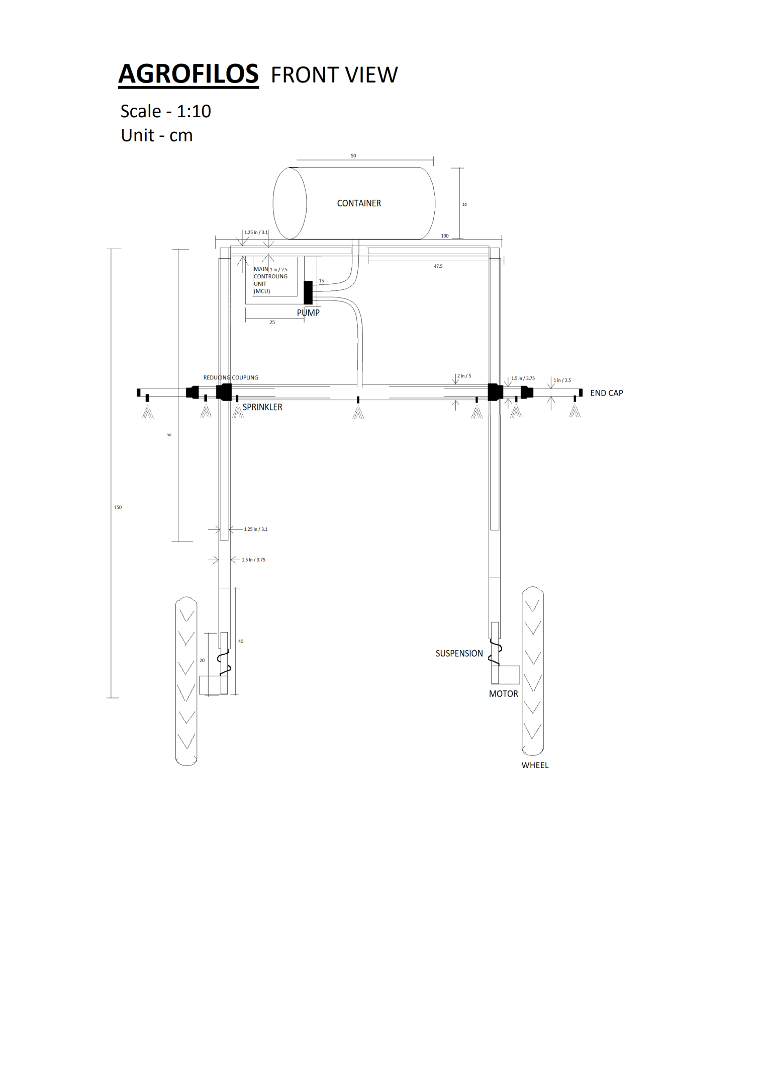

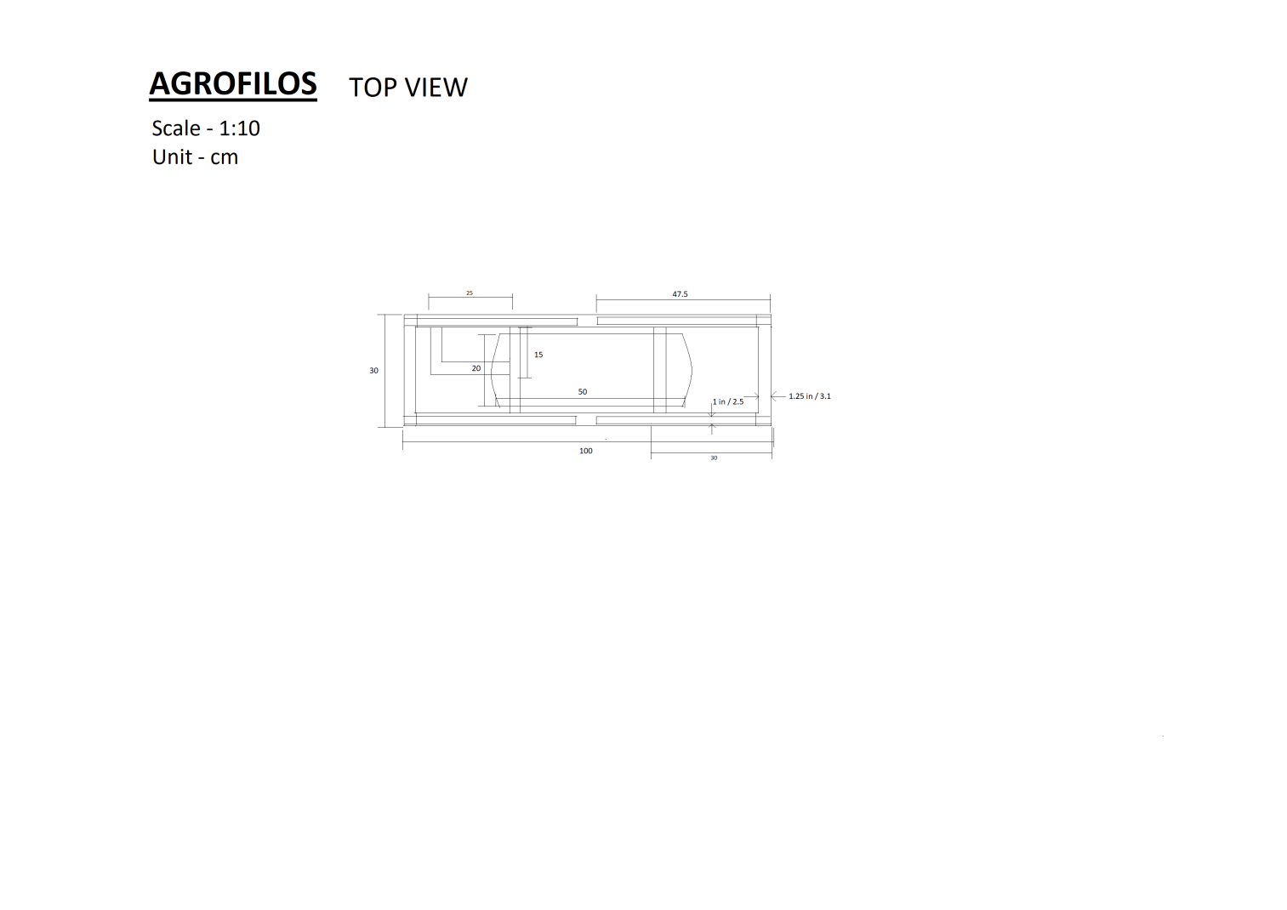
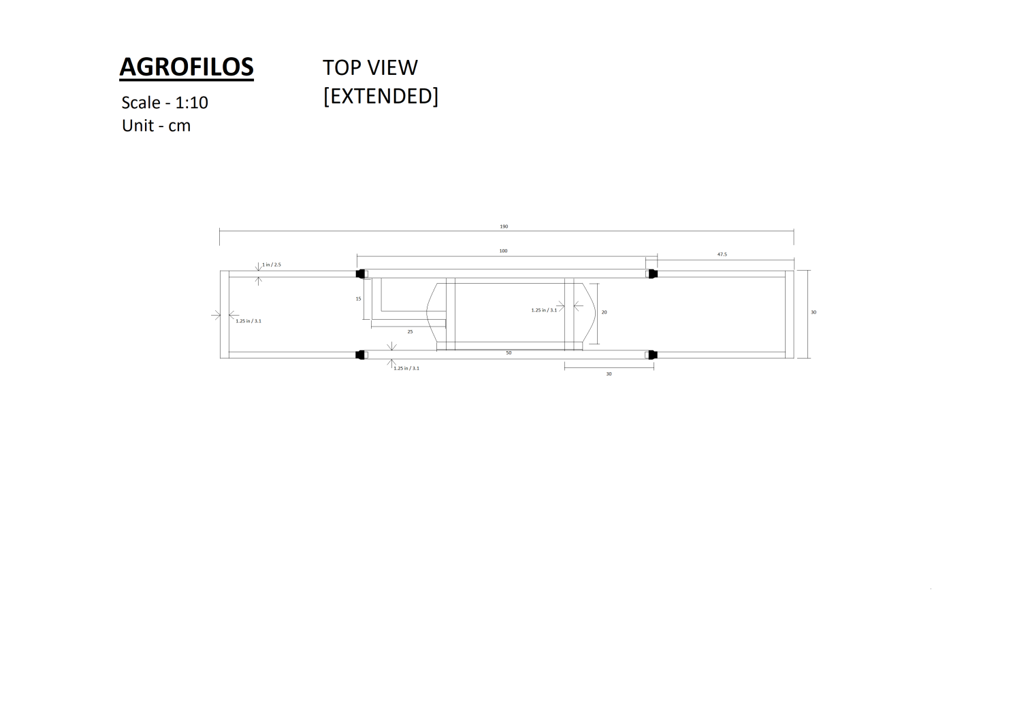
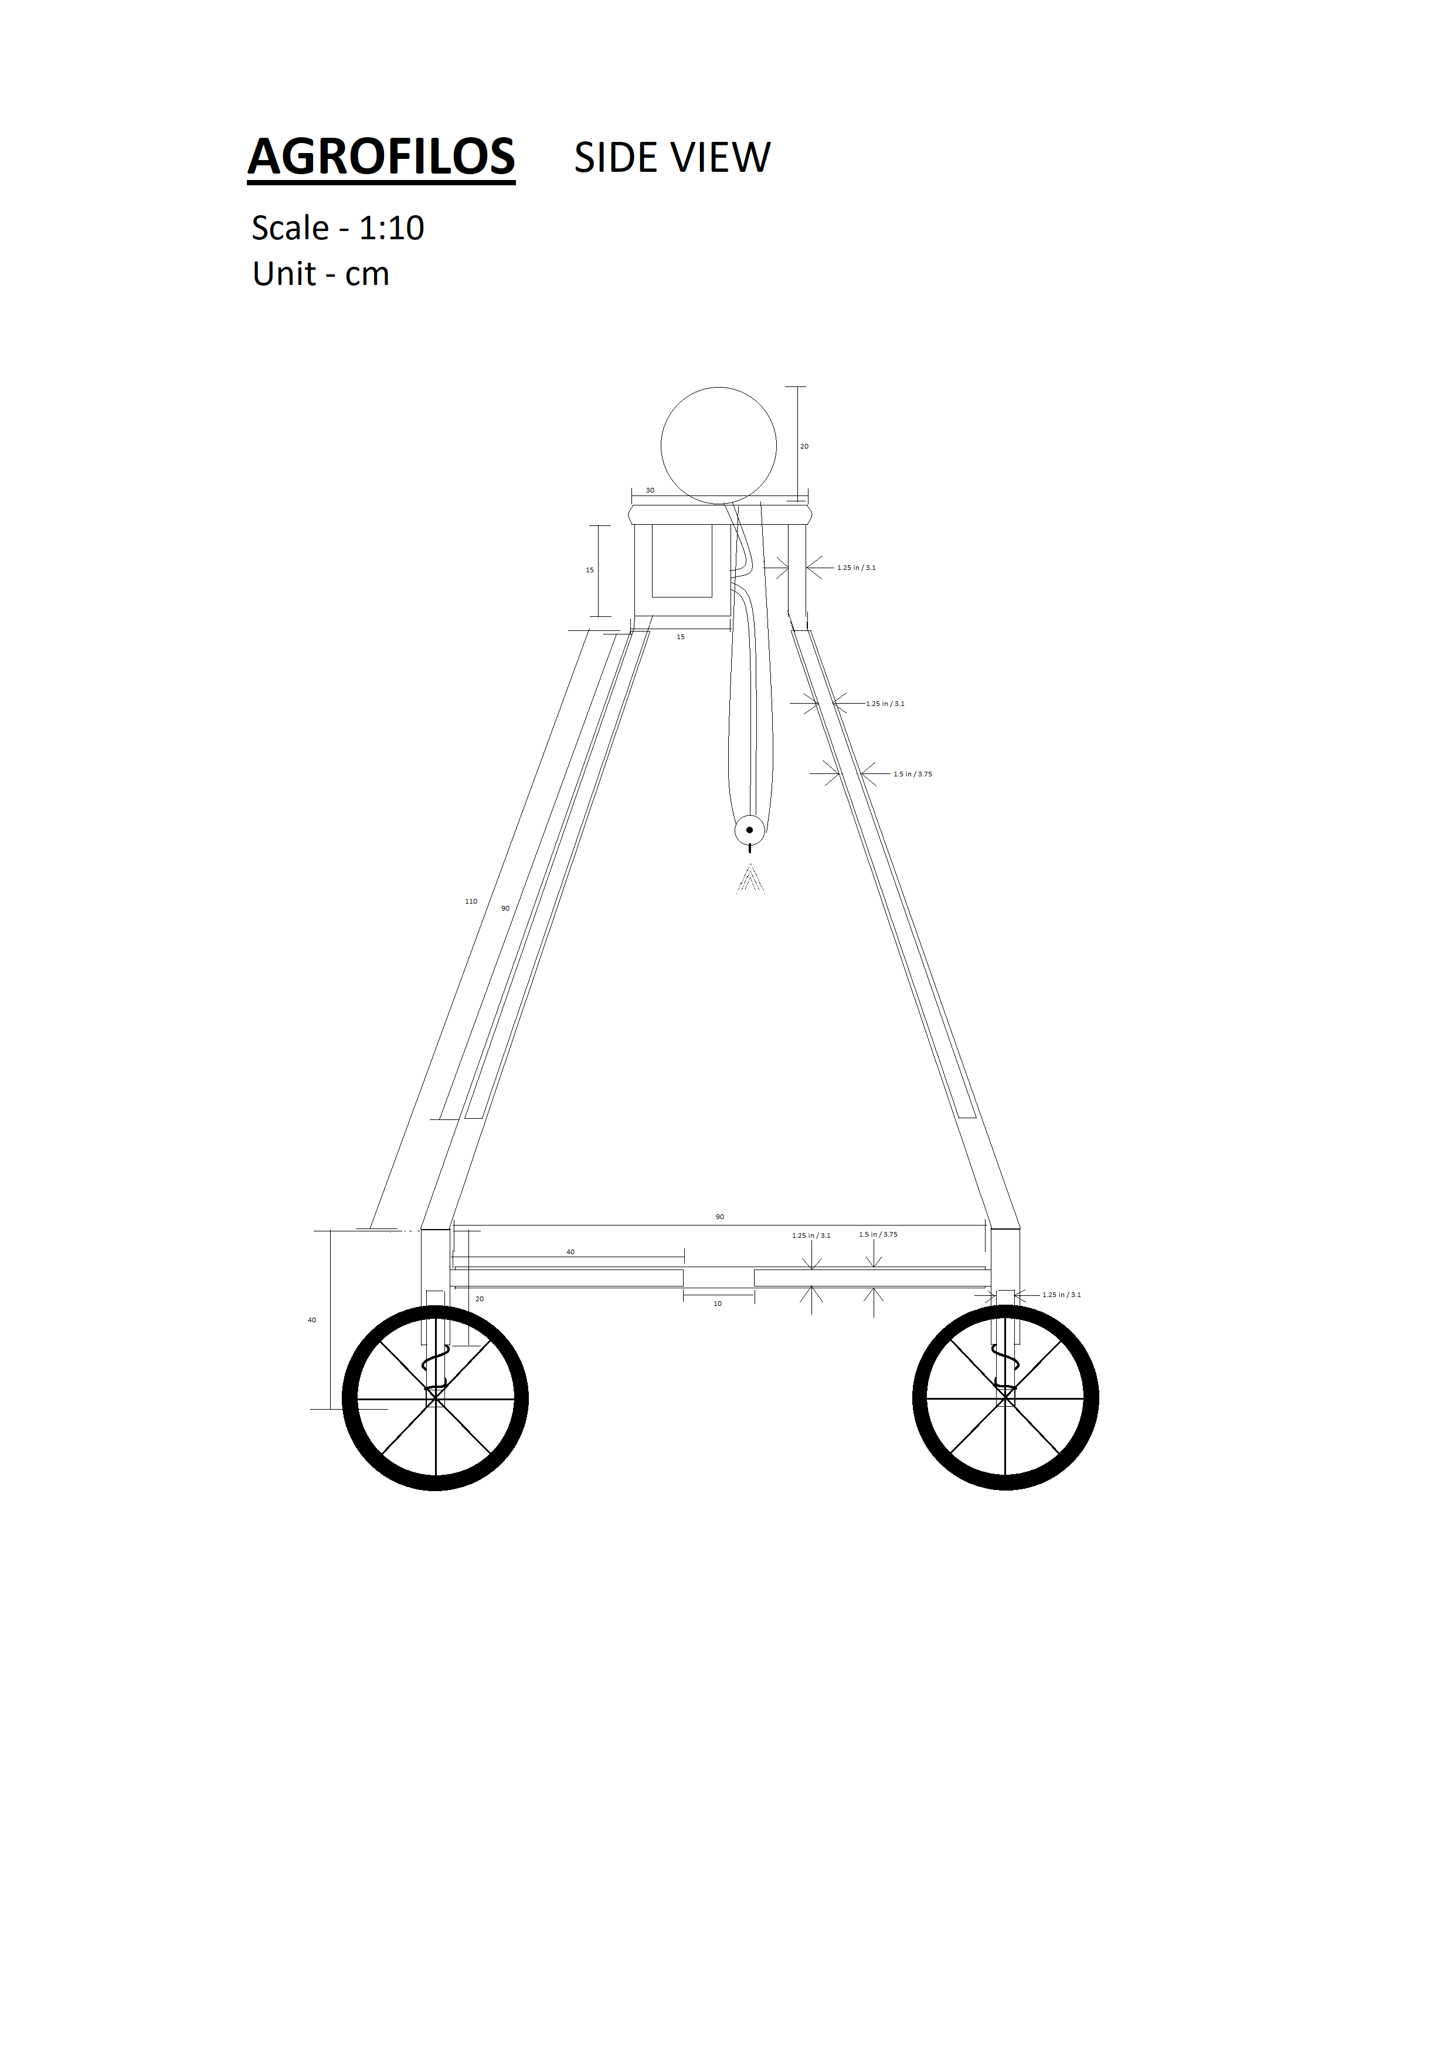

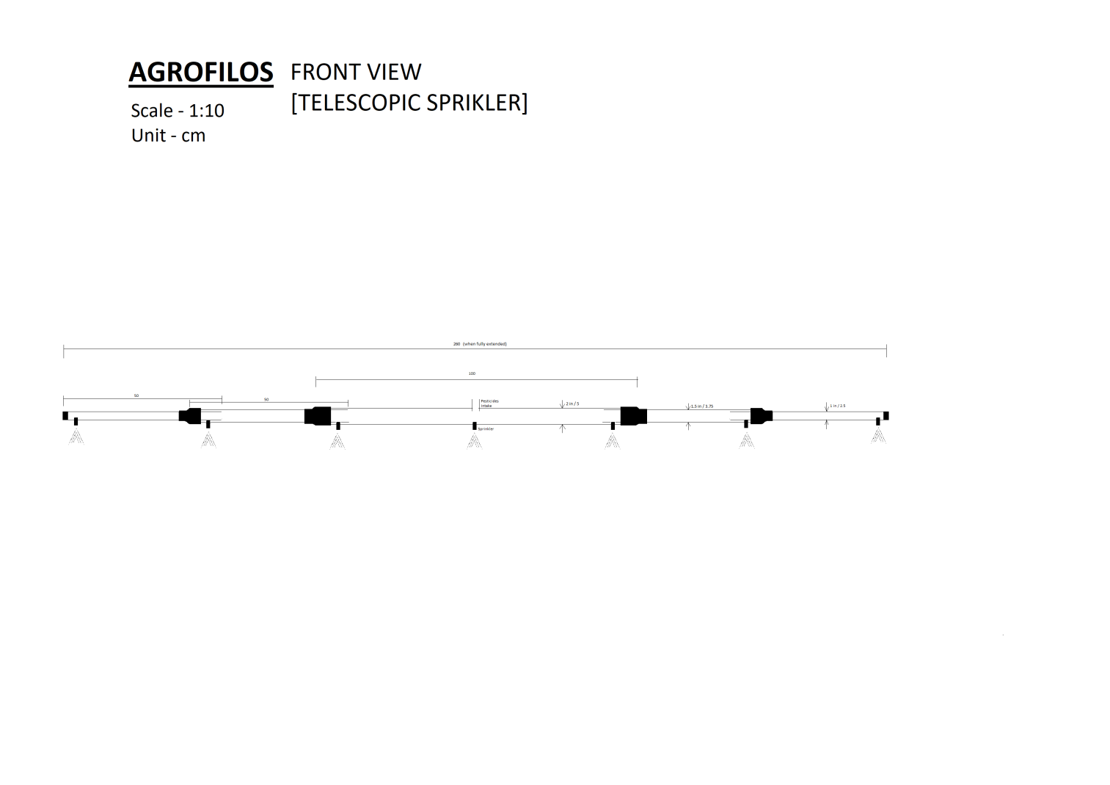
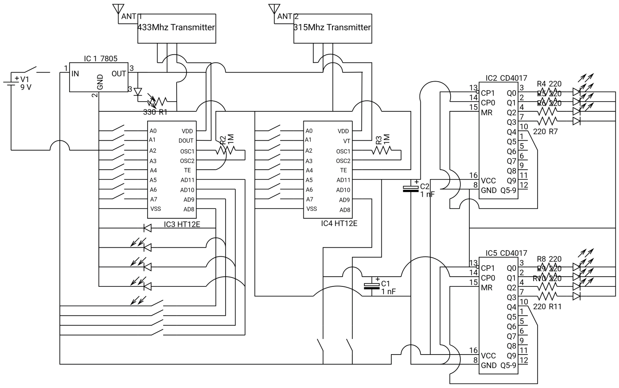

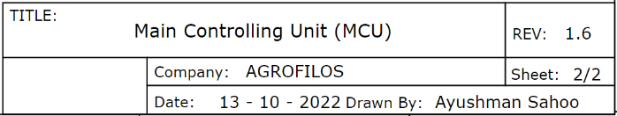
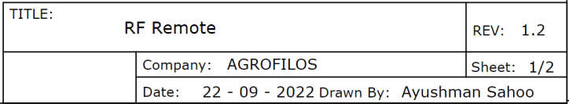
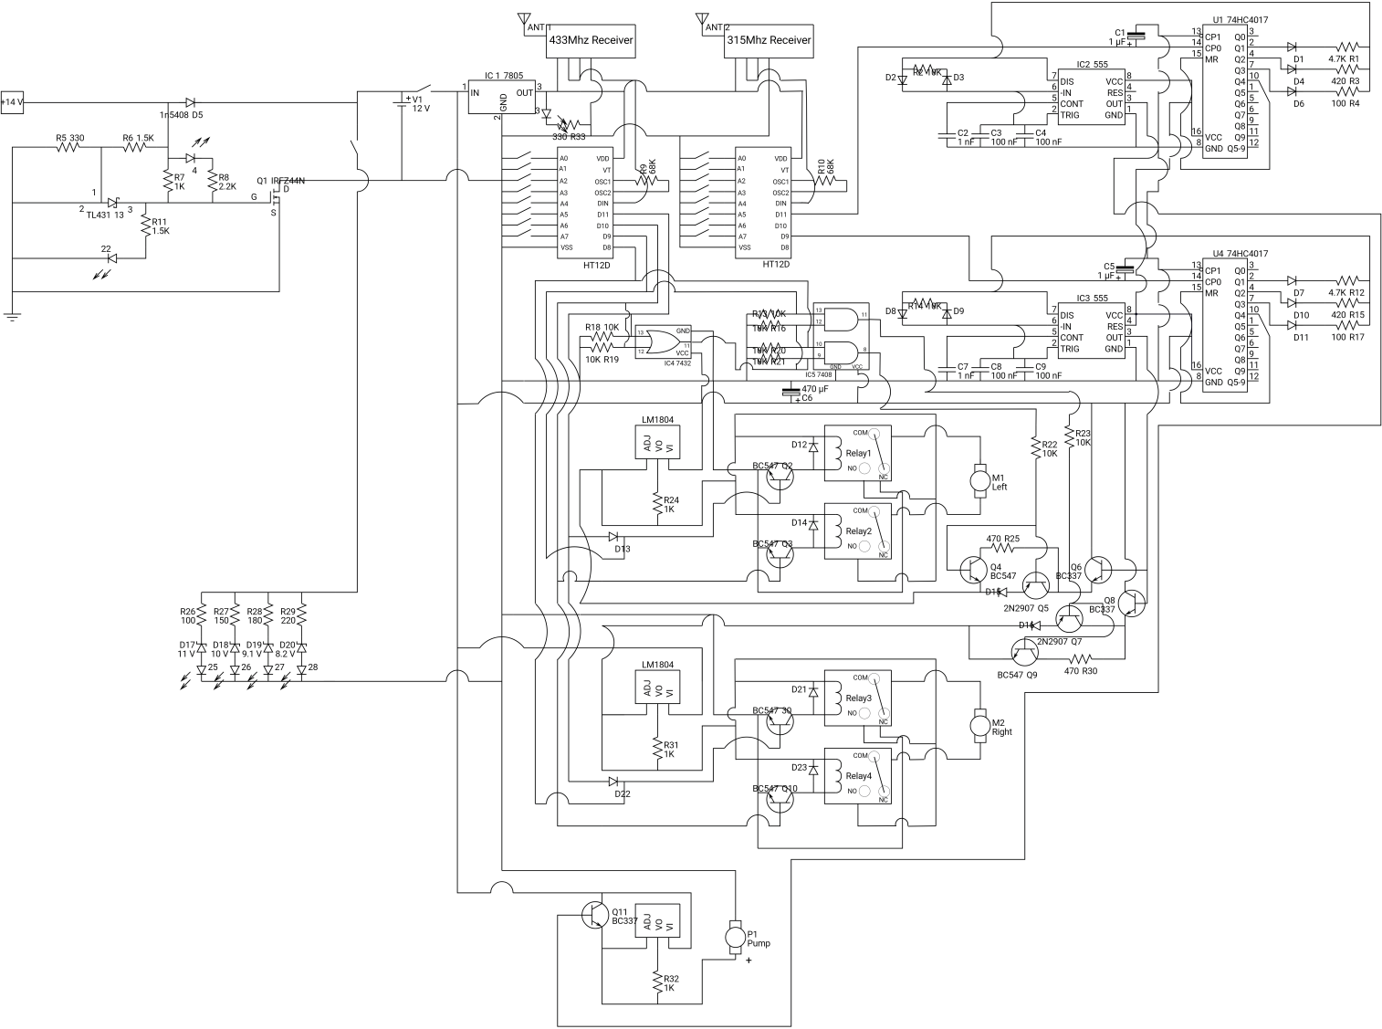

- Signature of all the applicant(s):

Certificate to be provided by your employer

This is to certify that the invention AGROFILOS is the work of the applicants (list all the names as given in theapplication form along with affiliation) and is recommended for filing patent in India by NRDC. This invention is/is not an assignment of employment.

Signature of the Head ofOrganization
Date:

Place: Seal

Duly filled-up applications may kindly be submitted to Manager & In-charge-NRDC-IPFC&TISC, Visakhapatnam, NRDC-MoMSME – IPFC&TISC, 1st Floor, Innovation Valley HillNo-3, Plot No 13 &14, Rushikonda, Visakhapatnam, Andhra Pradesh-530 045. E-Mail: bksahu@nrdc.in; Mobile: 9810104163

